Results with outliers
Results and considerations about the statistical analysis performed on the results of the dataset collected during the listening test session

Pre-processing of data
The two MATLAB files “complete_woofer.m” and “complete_tweeter.m” orders the data from listener 1 to listener 15 in two 15x36 matrices (where 36 is the number of the total ratings for each track and each speaker). Then the file “circshiftback_results.m” shifts back the results (according to the same logic was behind the GUI) in a way that on each row for all the 15 listeners we have the following sequence of data (independently on the randomization in the presentation of the stimuli that occurred during the test):
Where the first, second and third digit stands for the number of speaker, track and attribute respectively. Finally, in the “ONEWAYanova__with_outlier.m” file, the data is separated for each attribute in this way:
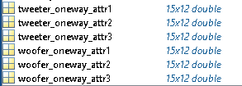
Where each of these matrices contain the evaluation of all 15 subjects only on a particular attribute, both for woofers and tweeter. Then a one-way ANOVA on each of these transposed matrices is performed in the following way.

Descriptive statistics/check for assumption test)
The purpose of the analysis at this level is to obtain an overview of the collected data
checking the statistical assumptions, identifying outliers and summarizing the observations in the form of mean values and associated variances. Four statistical issues need to be addressed before any analysis is conducted [bech2006]:
- Independence of observations
This has been controlled by means of statistical experimental design [bech2006] (see “Statistical experimental design paragraph
– cross reference here (parte ancora non scritta della tesi)).
- Homogeneity of variance across tested combinations of independent variables
We want the population variances in each group to be equal. The homogeneity of the variance of the residuals can be easily checked by using Bartlett and Levene test in MATLAB. However we have to remember that a low p-value indicates that vartestn rejects the null hypothesis that the variances are equal across all five columns, in favor of the alternative hypothesis that at least one column has a different variance [https://it.mathworks.com/help/stats/vartestn.html#btuo7w_]. So, what we want is that the p-value for each of the 6 tests is greater than the significance level in this case, that is what happens with our dataset. Moderate deviations from the assumption of equal variances do not seriously affect the results in the ANOVA. Therefore, the ANOVA is robust to small deviations from the HOV assumption. We only need to be concerned about large deviations from the HOV assumption. [http://www.math.montana.edu/jobo/st541/sec2e.pdf]
The homogeneity of variance assumption is also important for performing the Tukey HSD post-hoc testing.
- Normal distribution of repeated observation
The distribution of the original data, in our case a group of 15 listeners, will be determined by their mean values and can or should not be normally distributed, but the repeated ratings for each of them should be [bech2006]. In other words, we want to be sure that the dependent variable is normally distributed in each group that is being compared in the one-way ANOVA test (technically, it is the residuals that need to be normally distributed, but we can understand now that the results will be the same). This check should preferably be performed both graphically:
- Review the distribution (via histograms, boxplots, QQ plots)
Histograms are not so much informative for our case in which each listener performed only $36/3 = 12$ independent ratings on each attribute for every speaker (woofer or tweeter) as the plot would be too coarse. A quantile-quantile (Q-Q) plot, shows the distribution of the data against the expected normal distribution represented as a straight line on which observation should lie for normally distributed data or, vice versa, deviate noticeably. In our case, a total of 15x3x2 Q-Q plots (each listener for each attribute for both categories of speakers) should be inspected which is an impractical manner of proceeding. Normal distribution of data will translate instead in a symmetric boxplot around the mean and median in the center. Anyway, inspection of these plot will be considered later in the context of detection of outliers.
- Analyze the skewness and kurtosis
As a matter of fact, this can be performed simply calculating these value for each group of data and comparing that value with typical values for 3rd and 4th order central moment for a normal distribution or statistically as well with a dedicated test called “Jarque-Bera Test”. We chose this second way.
and statistically:
- Several numbers of statistical tests exist for testing the deviations from normality: basically, the hypothesis is that the distribution is normal, and this can only be rejected or not as any usual statistical tests. The only difference is that, like in the HOV test, testing for normality works in the opposite “usual” statistical test as far as p-value is concerned. This is because typically, we are interested in finding a difference between groups then we ‘look’ for small probabilities. When testing normality instead, we are not ‘looking’ for a difference, but we want our data set to be non-different than normal, so we want to accept the null hypothesis. [http://webspace.ship.edu/pgmarr/Geo441/Lectures/Lec%205%20-%20Normality%20Testing.pdf] Different tests show different statistical power according to the size of samples and other variables. For example, Shapiro–Wilk one has good power in fairly small samples [https://stats.stackexchange.com/questions/324795/normality-test-on-small-samples] [https://stats.stackexchange.com/questions/324795/normality-test-on-small-samples]
The one-way ANOVA is considered a robust test against the normality assumption. [https://statistics.laerd.com/statistical-guides/one-way-anova-statistical-guide-3.php]
This means that it tolerates violations to its normality assumption rather well with only a small effect on the Type I error rate. However a distribution with "lighter tails" than a normal distribution for our data can have a profound effect when our group sizes are small [https://stats.stackexchange.com/questions/5680/can-i-trust-anova-results-for-a-non-normally-distributed-dv].
However, in our case, even if the dataset size is small, we focused our attention in 4 different normality tests easily performed thanks to a MATLAB function called “normalitytest.m” available for free at:
(CITARE QUI)
Data referring to each subject’s ratings can be considered to be normal for woofers as the test resulted statistically positive and significant for more than the 75% of the data (individual listener ratings) for all the three attributes. The “Jarque-Bera Test” even considers each data of each group as normal.
Same exact considerations apply for tweeters, but there was only one problem in checking normality with the test for the ratings for attribute 2 from the listener 12 involved in the test. In fact, as we could also see in the correspondent boxplot distribution of data follows the extreme case of being non-normal in the sense that he scored the exact same value of 0.5 for every speaker-track combination. Listener 12 can be considered an outlier this reason.
- Detection of outliers
The tradition in statistics is to label an observation ‘outlier’ if its value is higher than 2.5 times the standard, so it is recommended to also use the box plot as a further aid [bech2006]. Box-plot results for the dataset can be checked using the same anova1 function in MATLAB used for calculating the ANOVA model.
Woofers:
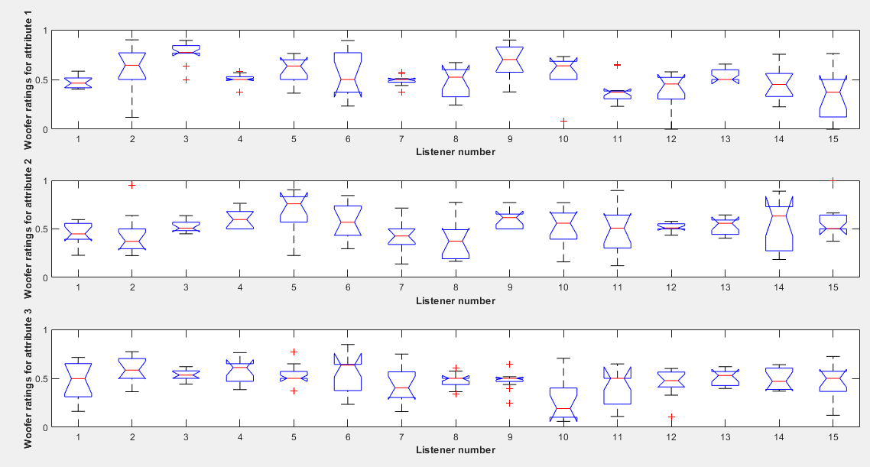
Tweeters:
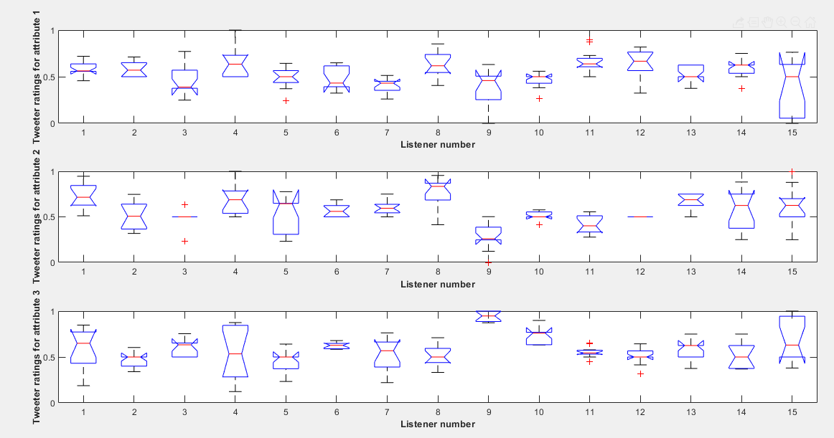
Neglecting considerations about multiple comparisons of group means that will be investigated in the post-hoc testing part
We can do considerations about:
• Main box width (extreme cases)
- For attribute 2 from the listener 12 in tweeters score coincides always with 0.5
- For attribute 2 from the listener 3 in tweeters is almost the same trend of above
In all other cases the “main box” is “large enough” to consider data significant.
• Single outliers
No more than two outliers for each group of data are present in the data for each group.
• Biased distribution of ratings towards a certain value
Other considerations are about balanced or unbalanced distribution of ratings for each listener. We can see that for attribute 1 on woofers dataset, listeners 4,7,11,13 have a median value very close to one of the upper or lower quartiles (the 25% quantile is even coincident with the median value for 4 and 13) meaning ratings very biased towards a particular value. This phenomenon happens also for rating of listeners 12 and 15 for woofer ratings on attribute 2 and for listeners 6 and 11 on attribute 3. For what concerns tweeter boxplots, on attribute 1 listeners 1,3,10 and 13 behave like that, on attribute 2 listeners 5 and 9, while for attribute 3 on listeners 2,5,10,12,13.

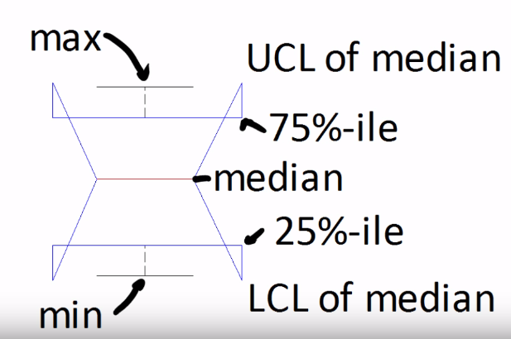 (For interpreting box-plot in MATLAB)
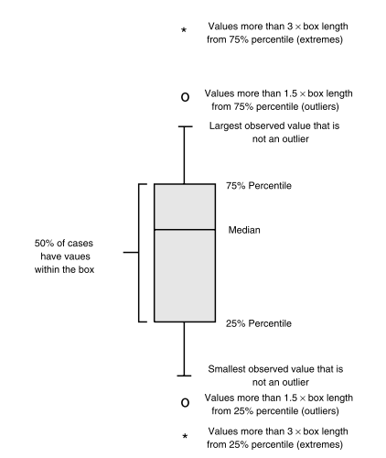[bech2006]

ANOVA
A listener’s performance can be quantitatively measured by statistically performing analysis of variance (ANOVA) on each individual listener’s data; the error variance and F-statistic scores can be computed to establish who are the most discriminating and reliable judges of sound quality [Fazenda2015]. ANOVA uses a single hypothesis test to check whether the means across many groups are equal. The null hypothesis $H_{0}$ is that the mean outcome is the same across all groups where the alternative hypothesis $H_{A}$ is that at least one mean is different. In our context of statistical methods for audio experiments we focus on answering one question: is the variability in the sample means so large that it seems unlikely to be from chance alone? After all, if the group means don't vary, or don't vary by more than random chance allows, we cannot say the means are different [herre2015]. We want to reject the null hypothesis. In fact, it is customary to subject the data to a significance test to determine the probability (expressed as the p-value of significance level) that experimental results could have occurred from chance, due to errors in the measurements or, in our case, performance of the listener [borwick2001]. In our case, if we have each column representing all the ratings for that particular attribute performed by listener $i$ ($i=1,2,…,15)$, the ANOVA checks the hypothesis that all the means of the ratings are the same (for the 15 listeners) giving a percentage probability that they all belong to the same population. This is output in p-value in the table whose meaning is explained in a while. In our dataset, framed in such a way, there is only one factor (or “group”) made of 15 listeners (independent variables) affecting the ratings (dependent variable) so is a univariate one-way ANOVA. We are asking ourselves how much the subject performing the test (the only one factor that could make the ratings mean different!) influences on the rating for each of the three attributes independently on the track or speaker. Mathematically speaking, the model for the t,i’th score from a subject is:
$$Y_{t,i}=μ+α_{t}+ε_{t,i}, { ε}_{t,i}\sim N\left(0,σ^{2}\right)$$
where $μ$ is the overall mean, $α_{t}$ is the between-groups treatment effect and $ε_{t,i}$ represents the within-groups or error effect [bech2006].
In our case, we are dealing with the deviation (variability) related to differences between the mean values of the listener ratings, often termed as between-groups deviation (columns of our matrix of data)and is in fact expressed in the row “Columns” in the ANOVA table results. The random deviation is instead the deviation caused by the repeated ratings of each listener for each loudspeaker-track combination and is denoted as within-groups (or error deviation) and is expressed by the row “Error” in the results. Three one-way ANOVAs for woofers have been performed both with a MATLAB script and a python code with another stat library for a double check of the results:
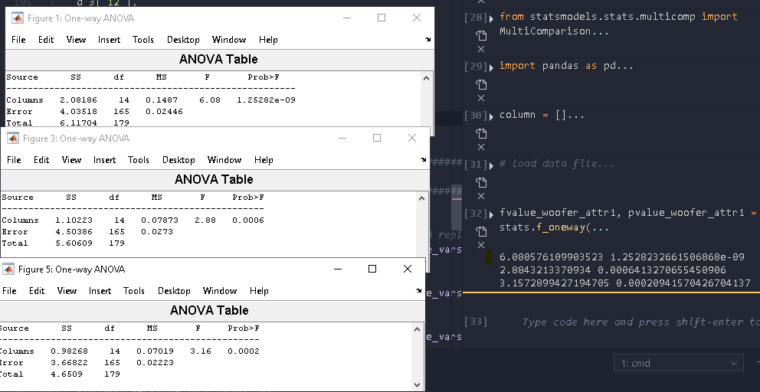
The three one-way ANOVA for tweeters has been performed only with the MATLAB script:
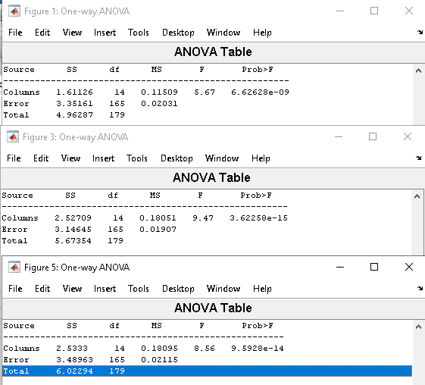
A one-way ANOVA table includes an identification of the dependent variable (rating) and six columns. The first column identifies the source of variation (the $α_{t}$ and $ε_{t,i}$ effects in the ANOVA model) followed by the sum of squares (SS) corresponding to each of the effects, the degrees of freedom for each element, the ‘mean square’ equal to $\frac{SS}{df}$, the magnitude of the ratio of the variances or the F-test value and, finally, the significance level corresponding to the F-test value and associated degrees of freedom [bech2006].
The p-value is the probability that the test statistic can take a value greater than the value of the computed test statistic. A small (in case of tweeters very small!) p-value indicates that differences between column means are significant. A p-value below the significance level (by convention $α=0.05$) means that we have a statistical significance evidence that the means are not the same, that is, the listeners have significant different capabilities of rating according to our panel. In other words, this means that there is less than 5% chance that the results occurred by chance [borwick2001] (so that we should have considered them only noise), and therefore our dataset is statistically significant. The compliance of these results has also been checked for the F-value ($→$ see Appendix #).

Post-hoc testing
The ANOVA has suggested a significant effect for listeners, but to assess the difference in mean score between a particular pair of listeners the solution is running a series of paired comparisons i.e. run a stats analysis for each paired combination in our test [fazenda2015]. Identifying the pairs with a significant difference in mean values can be performed by testing each pair, one by one at a specified significance level, using the standard t-test as described in Section 6.2.4 [bech2006]. In such a multiple comparison test, as usual, we specify a significance level ($α=0.05)$that determines the cutoff value of the t-statistic. Multiple comparison procedures are designed to provide an upper bound on the probability that any comparison will be incorrectly found significant [https://it.mathworks.com/help/stats/multcompare.html]
However, there are two problems in applying an ordinary t-test comparison. Firstly, when there are many group means, there are too many pairs to compare, and, moreover, the same $α$ value would apply to each comparison, so the chance of incorrectly finding a significant difference would increase with the number of comparisons. The relationship between the number of comparisons and the corresponding overall Type I error level is formally given in [bech2006]. For larger groups of paired comparisons, it is better to use Tukey’s honestly significant difference(HSD (also performed in [Moulin2016a]). The Tukey procedure is based on a critical difference which is compared to the observed difference between a pair of means: if the observed difference is larger than it, it follows that the difference is significant at the applied $α$ level. The critical difference is given by a formula depending on some entry parameters such as the number of pairs to be compared and the test level $α$ itself [bech2006]. Tukey’s honestly significant difference procedure is optimal for balanced one-way ANOVA and similar procedures with equal sample sizes.
As our data meet the assumption of homogeneity of variance, a Tukey test has been performed with the MATLAB function ‘multcompare’ which provides an interactive tool for identifying which group are more significantly different in means.
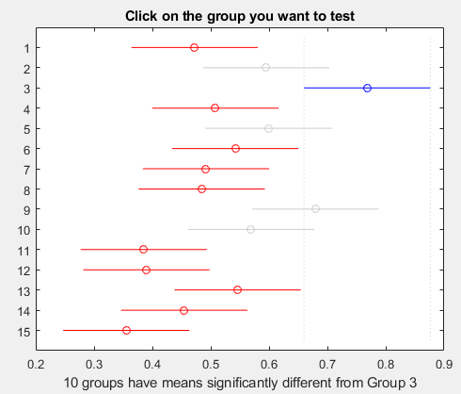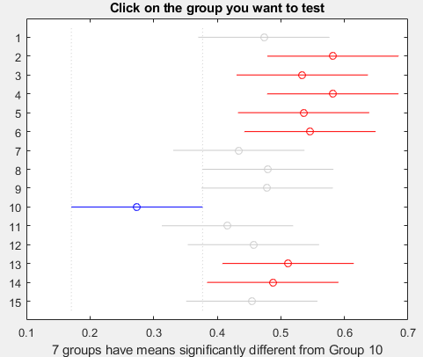
(woofer_attr1) (woofer_attr3)
As far as woofers are concerned, for the ratings of the first attribute “loudness”, listener 3 performed very differently from almost every other subject involved in the test. Moreover, listener 9 scored the results significantly different from listeners 11,12, 14 and 15 while listener 15 seems to be significantly far away from the ratings of listeners 2,3,5,9. (figure on left) For the second attribute “timbral balance” the only thing that does worth highlighting is that listener 5 performed very differently especially from listeners 1,2,7,8. For the third attribute “preference” we can see that almost 7 listeners performed significantly different from listener 10 (figure on right)
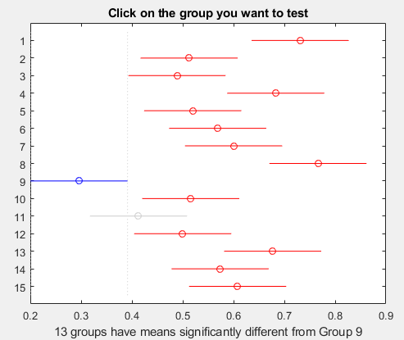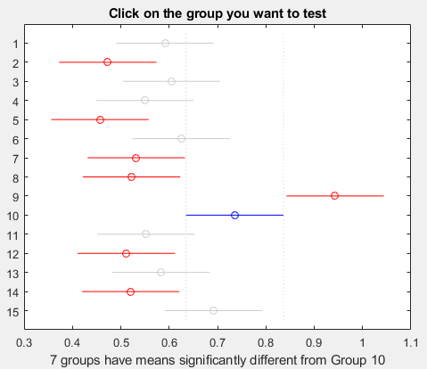
(tweeter_attr2) (tweeter_attr3)
Examining tweeters results in the same manner, for the ratings of the first attribute “loudness”, listeners 7,9,15 have significantly different means in score with respect to listener 4, listeners 4,8,11,12 performed differently from listener 7,9,15 in a non-trascurable manner.
For the second attribute “timbral balance” listener 1 is significantly different in mean with respect to seven other listeners, while listener 9 has a mean evidently far away from all other thirteen mean scores. A total of 5 listeners have also means significantly different from listener 11. For the third attribute “preference” is evident that listener 9 has a significantly different group mean with respect to all the other listeners, while listener 10 is significantly different from other seven groups.

CONCLUSIONS
What has been important is the inferring of the trustiness of our data set through the “collaboration” of different statistic techniques, each one highlighting a different aspect in the dataset itself.
• DESCRIPTIVE STATISTICS RESULTS
INDIPENDENCE OK
HOV OK
NORMALITY OK
OUTLIERS SEE BELOW
• ANOVA RESULTS
p-VALUE + F-VALUE OK
• POST-HOC TESTING RESULTS + (DETECTION OF OUTLIERS (in descriptive statistics))
Woofers
attribute 1 $→$(listeners 3, 9, 15 outliers?)*
attribute 2 $→$(listener 5 outlier?)*
attribute 3 $→$(listener 10 outlier?)*
Tweeters
attribute 1 $→$ ?*
attribute 2 $→$ (listener 1,9 outlier?)* + (listener 12 outliers)**
attribute 3 $→$ (listener 9 outlier, listener 10 outlier? )*
* = from Tukey post-hoc testing SI MA NON E’ RITENUTA SUFFICIENTE COME DIFFERENZA PER CONSIDERARE IL GRUPPO UN OUTLIER
** = from boxplot inspection
Results of Tukey HSD are compliant with the box-plot visual inspection.

Appendix #
In general statistical terms, the F-value is a ratio of two variances, and, in our case of one-way ANOVA, the F-statistic is the ratio of the variation between the group means to the variation between the samples. One-way ANOVA calculates a mean for each of the fifteen group (listeners) that are distributed around the overall mean for ALL the observations. Asking for means to be apart one another can be performed with the mean squared error $MS=\frac{SS}{df}$, where $SS$ is the sum of squares deviations, and $df$ is the degrees of freedom in the model. In particular, referring to the nomenclature provided by the MATLAB output tables, we call the variance between sample means $MS_{columns}$ while, for estimating the variability within each sample (how far each rating is from its group mean for each of the 15 listeners) we will have a $MS_{Error}$. The F-statistic is the ratio of the mean squared errors $\frac{MS_{Columns}}{MS_{Error}}$ (in the above figure $\frac{0.11509}{0.02031}≅5.67$) accordingly to the definition of the metric.
As far as the numerator is concerned, if the group means are clustered close to the overall mean, their variance is low, while, if the group means are spread out further from the overall mean, their variance is higher. For what concerns the denominator, if the observations for each group are close to the group mean, the variance within the samples is low. However, if the observations for each group are further from the group mean, the variance within the samples is higher. If we’re hoping to show that the means are different, it's good when the within-group variance is low (very collected ratings for each listener, that is, very low background noise in the results). [https://blog.minitab.com/blog/adventures-in-statistics-2/understanding-analysis-of-variance-anova-and-the-f-test]
For one-way ANOVA, the aforementioned ratio (F-statistics) follows an F-distribution when the null hypothesis is true. Placing the F-value of our study in the F-distribution curve the consistency of our results becomes only a matter of calculating probabilities, in particular, the probability of observing an F-statistic(or F-value or F-ratio) that is at least as high as the value that our study obtained that we can call $F_{critical}$. The shaded area in figure below represents that probability which is commonly known as p-value.
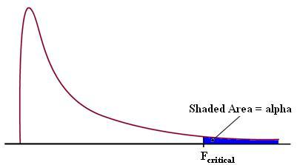
[https://www.statisticshowto.datasciencecentral.com/wp-content/uploads/2013/09/f-table.jpg]
The lower that probability the more likely our data are to be contradictory with the null hypothesis and can be seen also graphically that this coincides in having a high F-value in our result. This probability is “low enough” to reject the null hypothesis according a common significance level of $α=$0.05.
So, in the F-statistic the ratio of the two quantities involved is expected to be nearly unitary under the null hypothesis, leading to an F-statistic of approximately 1 (variation between group means is the same that within samples). If we want to show that the means of the groups are different (in order to reject the null-hypotesis that the group means are equal) we need a high F-value so the further we are from $1$ the better is for our dataset. Basically, the p-value and the F-value tell us the same information as they are the two faces of the same coin. In our case the worst case in this sense, is represented by the F-value for ratings on attribute 2 on the woofer dataset, which is just above the minimum “allowed” value.
We know that in the ANOVA test the ratio of variances involved to calculate the F-metric uses degree of freedoms to which we can have access in the table of results. A MATLAB function also exist to find a value that should exceed a certain percentage of the samples from an F distribution with some degrees of freedom in the numerator and some other degrees of freedom in the denominator. These are the three inputs of the function. [https://it.mathworks.com/help/stats/finv.html]
In particular, if we use the function with the degrees of freedom of each of our ANOVA test (the same for the all 6 tests) and a probability of 95% (0.05) we can say that we would observe values greater than the value obtained only 5% of the time by chance, that is, we are very likely to obtain a value greater than this almost every time and this value in our case is a bit greater than 1. As a final countercheck we can see that the result of the finv function (1.7521 in our case) is greater than 1 and smaller with respect to any F-value occurred in each ANOVA test.

The median value is the value at which 50% of the observations are higher and 50% are lower. The median is also termed the 50th percentile or the second quartile. Percentiles divide the distribution into groups of specific sizes. The 25th percentile is thus the value at which 25% of the observation falls below and 75% falls above. The interquartile range is the difference between the 25th and 75th percentile
The terms “error” comes from the fact that represents the variability not explained by the factor we are dealing with (listeners).

